Name-Rochelle Fernandes

Do you like festivals

Rochelle Fernandes of age 41 likes festivals a lot.

What is Festival according to you

According to her festival is a time to celebrate with family and friends.

Which is your Favourite festival

Her favourite festival is ‘Christmas’.

Why is it your favourite festival

According to her it brings a lot of cheer in the family.
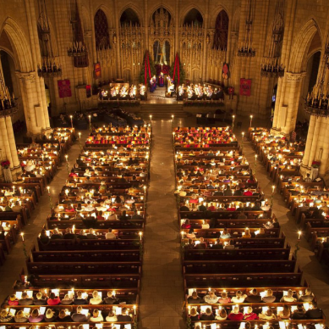
What is the importance of the festival in our lives?

The importance of this festival in our lives is that we get to meet our
family during this festival and get to make sweets like cake and cookies.

What is the best thing about this festival that you like?
The best thing about the festival that Rochelle Fernandes likes
is the Midnight Mass that takes place and the sweets that she gets to eat.

How important are these festivals in your house/ community?

Christmas is very important in her life and her locality where she lives.

During the pandemic did you feel left out from the enjoyment of the festival

During the Covid-19 pandemic she does feel left out from the abundant fun activities that happen in the festival like many others. She cannot even meet her family.

