MAIN QUESTION: How important are celebrations in your family /community?

Celebrations are in fact a brilliant and joyful way to show people what you believe in. It is very important for us to celebrate with our families and friends. It is time for families and communities to come together have fun and an opportunity for activity, conversation, laughter and excitement.
The family and community heritages often stem from generations of sharing. Celebrating events like birthdays, anniversaries, festivals or even if you’ve graduated, finished a major project, or received a promotion allows people the chance to feel like they've achieved something significant, that their commitment to each other holds value. It is a great way for rewarding ourselves for a job well done. Traditions make life more meaningful and are unique to each family. It helps us build

strong relationships between generations and among people because these customs are so cherished, children often remember these special experiences from the more than the gifts they receive. It teaches important values and it is always nice to look forward to time with your community and to participate in ongoing traditions.
No matter what your tradition is or what your family / community chooses to create, just having something for everyone to look forward to each year is important. Traditions help create warm, positive memories that can be recalled fondly and draw people back to one another year after year.

Methods:
We invited about 100 people by sending them Google Forms, WhatsApp messages, E-Invites and MS Teams invites.
About 50% people responded, some energetically participated, few a little hesitant and few not in favor of sharing their personal views.

QUESTIONNAIRE:
1)What is the importance of celebrations in life?
2)Which festival do you love to celebrate and why?
3)How do you like to celebrate your birthday?
4) Why do we celebrate?
5)What are the main celebrations in your country?
6) Which holiday do you like to celebrate the most? State its importance
7)Why are celebrations unique?
8)What is the Independence Day ? What according to you is the reason behind celebrating it ?
9) Do you enjoy celebrating with your community/friends? Give an instance on how you celebrated.
10)Do you think celebrations are important during this pandemic?
11)Are the social gatherings and festivals becoming virtual worlds? How?
12)What is your best Christmas memory according to you?
13)People celebrate festivals in different ways. How can we make such celebrations eco-friendly?
14)Do you exchange gifts during Christmas/Diwali? If yes what is the coolest gift you have ever received
15) How have your relations with family and friends changed this year?
16)Which family tradition do you continue every year?
17)Do you have any special customs for New Year’s Eve or New year’s day ? What do you usually do?
18) Is there any special music for a particular festival in your culture?

HERE GO THE INTERVIEWS......
Interview: 1
The interview experience with my family members was truly an insightful one which explained to me for my understanding what it means to have a celebration in one’s life. It showed me it means different things to different people.
For my sister, Natasha Walanju it was special because it meant to her to get together with her near and dear ones. She shed some light on the different types of festivals that take place in India like Christmas, Ganesh Chaturthi, Diwali, Holi and how social gatherings are a huge part of these festivals. Natasha said that all gifts are special because they are given with so much love from her loved ones.

Interview :2
The other person I interviewed was my aunt who being more spiritual had a different view on celebrations and festivals which she explained the meaning of each celebrations in detail and why it is important to celebrate.
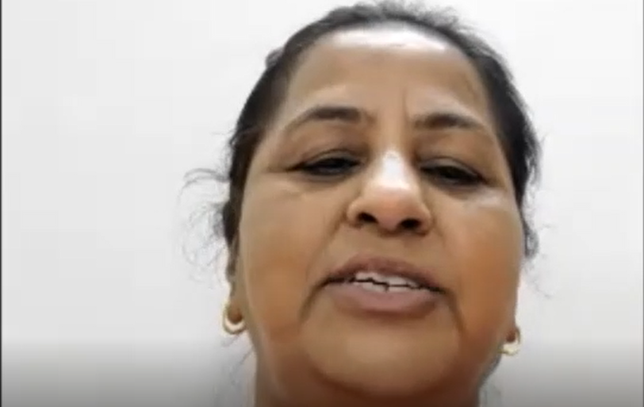

Interview :3
Name: Karina
Age:13
I ask my friend Karina some questions about celebrations and here’s how they turn out.
Q1. Which festival do you love to celebrate and why?
Ans: Karina’s favorite festival to celebrate is Easter. She feels that every year on Easter she is forgiven for the sins she has done, and it purifies her soul and she is reborn as a new person. She feels that she has a fresh mind and is ready to do anything.
Q2. Do you think celebrations are important during COVID-19?
Ans: She feels that celebrating festivals is very important during this pandemic. She feels so, as many people are spending time away from their families and festivals provide us with an opportunity to reconnect with them and share joy and happiness. She feels that festivals are the only thing people look forward to during this brutal pandemic to help them pass through this tough phase. Although festivals are important, she feels that the people should follow all the necessary norms given to avoid coming in contact with the virus.
Q3. What is the most favorite gift that you have received?
Ans: Karina says that she received her most favorite gift during Christmas, 4 years ago.
The present was a dog, which her family named Mickey. She said that she was very happy and excited to welcome a new member to her family. She feels that Mickey has changed her life drastically. She believes that her family trust each other more because of Mickey and she has become more responsible. She says that seeing Mickey everyday makes her heart fill with joy and that a dog is the best present that you can ever get.
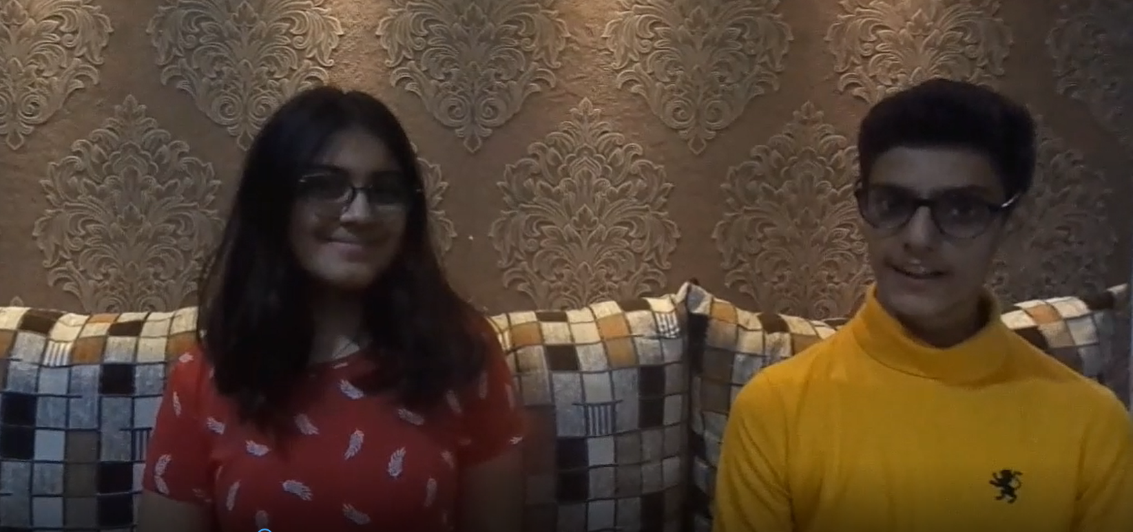

Interview :4
Name- Keshav Mohta
What do you think is the importance of the celebrations of festivals in our life?
Keshav replied to the question by saying that the festivals bring light and colour to the dark times we live in during Covid-19. It is the one occasion where we actually meet with our whole family. Keshav goes to his native place every year during Diwali and there he meets them.

What is the main celebration in your locality?
The one festival which they celebrate to a large extent is Diwali and, in their society, they celebrate Holi too.

Do you think celebrations are unique?
According to Keshav, none of the celebrations are unique as everyone celebrates it in a similar manner. Some people do have unique rituals but as such festivals are not unique.

Do you think the celebrations of the festival are still important before the pandemic and during the pandemic?
Keshav responds by saying that these festivals are still important to celebrate before and during the pandemic as before and during the pandemic, you still wouldn’t meet your family. Before the pandemic, you would have work, school, and stress, which would remain the same after or during the pandemic.
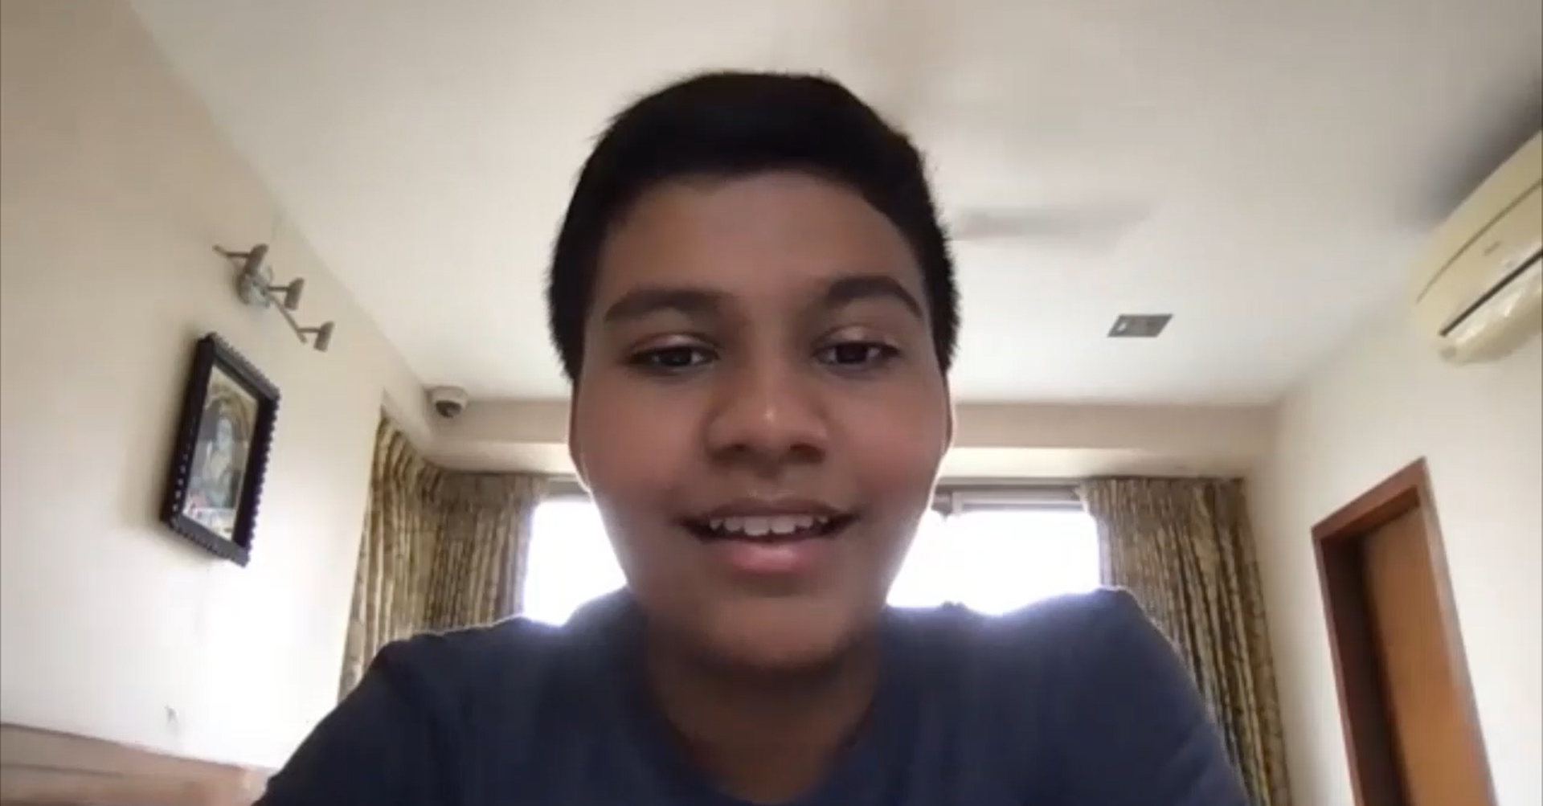
Interview: 5
My first interview was with Krushmi Rita.
Age: 18
My first question to her was how would she love to celebrate her favorite festival. She said she loved Diwali and would like to celebrate with her close ones of course, who doesn’t? who come over and spend the evening. She mentioned that she enjoys making savory snacks, sweets and colorful rangolis. She loved wearing ethnic wear and decorated her house with lights.
When asked how would she love to celebrate her b’day, she answered she would be delighted if her companions could come over at midnight, decorate her house and will cut a delicious cake with them.
In morning she’d like a brunch with her family and at noon spend time with her school friends. At night she would like to party and enjoy her day to the fullest.
My third question was if celebrations were important during this pandemic, she strictly replied saying no they weren’t important in this pandemic. Her health mattered to her. With her expressions I understood that she takes the pandemic seriously. She felt enjoying with her family at home and being safe was preferable rather than going out. She also said that the pandemic would last for few years and we should all take the necessary precautions.
Thus, concluded celebrations to be celebrated to a minimum during the ongoing times.
